

CAF Plan Phase for SQL Migration

**List of Contents**

1. Plan 3

1.1 Digital Estate 3

1.1.1 Determining Analysis Approach 3

1.1.2 Collect current state Inventory 3

1.1.3 Rationalize the assets in the digital estate 4

1.1.4 Align assets to cloud offerings to calculate pricing 5

1.2 Initial Organization Alignment 11

1.3 Skills Readiness Plan 11

1.4 Challenger Questions for Customers 12

1.5 Roadmap of Migration from IaaS to PaaS 14

# Plan

In this section, we are going to build a cloud adoption plan considering the business goals and make any changes across digital estate, skills and organization. The total cost of ownership (TCO) of the company’s entire applications portfolio will be assessed, identifying key patterns and select correct migration treatment for each application based on TCO report and application requirement. This section will specifically discuss the following:

## Digital Estate

A Digital Estate refers to electronic information assets that exist on the internet or collection of tangible owned assets like VMs, applications, data, servers etc. Every company has a digital estate in our case it is virtual machines, servers, database, application which plays direct role in powering businesses and supporting business operation. Planning a digital estate is the most obvious first step while you are migrating your digital estate to the cloud.

Below steps is considered as best way to plan digital estate:

* Determining Analysis Approach
* Collect current state Inventory
* Rationalize the assets in the digital estate
* Align assets to cloud offerings to calculate pricing

### Determining Analysis Approach

This section will introduce you to different way of analyzing the digital estate based on desired outcomes and size of the whole infrastructure.

* Workload- driven approach
* Asset – driven approach
* Incremental approach (Best One)

LINK: <https://docs.microsoft.com/en-in/azure/cloud-adoption-framework/digital-estate/approach>

### Collect current state Inventory

Developing an inventory list is the first step in digital estate planning. It consists of making a list of IT assets that supports specific business applications for later analysis and rationalization. In a cloud transformation, inventory directly correlates to operating costs. Accurate inventory data is required for proper planning.

Specifically, for migration you can collect the inventory from scanning tools that create a centralized list of all virtual machines and severs. Some tools can also create network mappings and dependencies, which help define workload alignment.

**Tools:**

* **Data Migration Assistant (**[**DMA**](https://docs.microsoft.com/en-us/sql/dma/dma-overview?view=sql-server-ver15)**):** Data Migration Assistant assesses feature parity between SQL sources and targets. It recommends performance and reliability improvements.
* [**Azure Migrate:**](https://docs.microsoft.com/en-us/azure/migrate/migrate-services-overview) Azure Migrate assesses the migration suitability of the machines. It provides sizing and cost estimates for running in Azure.
* [**Service Map:**](https://docs.microsoft.com/en-us/azure/azure-monitor/insights/service-map)Azure Migrate uses Service Map to show dependencies between machines that the company wants to migrate.

### Rationalize the assets in the digital estate

Cloud rationalization is the process of evaluating assets (digital estate) to determine the best approach to hosting them in the cloud. Rationalization of assets is also the most time-consuming process while designing cloud adoption plan. Before we discussed rationalization options it is important to understand Below 5 Rs of rationalization.

* **Rehost**: moving a current state asset to the chosen cloud provider, with minimal change to overall architecture.
* **Refactor**: Platform as a service (PaaS) options can reduce the operational costs that are associated with many applications. It's a good idea to slightly refactor an application to fit a PaaS-based model. "Refactor" also refers to the application development process of refactoring code to enable an application to deliver on new business opportunities.
* **Revise**: Some aging applications aren't compatible with cloud providers because of the architectural decisions that were made when the application was built. In these cases, the application might need to be rearchitected or Revise before transformation.
* **Rebuild**: In some scenarios, the delta that must be overcome to carry an application forward can be too large to justify further investment. This is especially true for applications that previously met the needs of a business but are now unsupported or misaligned with the current business processes. In over case, a new code base is created to align with a cloud-native approach.
* **Replace**: Solutions are typically implemented by using the best technology and approach available at the time. Sometimes software as a service (SaaS) applications can provide all the necessary functionality for the hosted application. In these scenarios, a workload can be scheduled for future replacement, effectively removing it from the transformation effort.

Below are the common rationalization options

**Traditional Method of Rationalization:**

This process can be visualizing as a complex decision tree in which leaf nodes are the 5 Rs and root nodes or intermediate nodes will be set of questions which categorizes each asset of the digital estate. First layer will be quantitative questions like if the particular SQL server in use today? if yes then is it optimized and sized properly? etc. The next layer will be qualitative questions to further categorize the assets which requires human intelligence and can only be answer by business stakeholder.

**Rationalization at enterprise scale:**

Above traditional method will be much more time consuming when we have thousands of VM and hundreds of applications So its best practice to hire professional services organization that specializes in cloud rationalization.

**Incremental Rationalization:**

In an incremental rationalization process, the cloud strategy team and the cloud adoption teams limit the five Rs of rationalization to two concise decisions and only apply those quantitative factors. This streamlines the analysis and reduces the amount of initial data that's required to make any decisions.

**Example**: if an organization is during an IaaS migration to the cloud, you can assume that most workloads will either be retired or rehosted.

By reducing the number of potential outcomes (5 Rs), it's easier to reach an initial decision about the future state of an asset. When you reduce the options, you also reduce the number of questions asked of the business at this early stage. The binary question is typically much easier to run through qualitative analysis. This streamlined approach produces baselines, financial plans, strategy, and direction.

The above rationalization methods are full of assumptions so the next steps will be challenging those assumptions, preparing our first workload to migrate. The first workload should have minimum dependencies and can be moved as a small group of assets. finally, the rationalization team should provide a complete release plan of the future workloads with proper sequence considering their dependencies.

### Align assets to cloud offerings to calculate pricing

In this section, we are going to build a costing model for each asset in the digital estate. These costing models will help you understand the cost associated with the migration of each application to the cloud with transparency and accuracy.

Below tools is used to monitor, allocate, and optimize cloud costs.

[**Azure Migrate:**](https://docs.microsoft.com/en-us/azure/migrate/migrate-services-overview)

Azure Migrate provides a centralized hub to assess and migrate to Azure on-premises servers, infrastructure, applications, and data.

Azure Migrate provides the following features:

* A single portal to start, run, and track your migration to Azure.
* Provides a range of tool for assessment and migration
* Assess on-premises servers and databases and migrate them to azure VMs and Azure SQL databases.
* Assess on-premises web applications and migrate them to Azure App Service by using the Azure App Service Migration Assistant.
* Assess your on-premises virtual desktop infrastructure (VDI) and migrate it to Windows Virtual Desktop in Azure.
* Migrate large amounts of data to Azure quickly and cost-effectively using Azure Data Box products.

Access and migrate VMware VMs

LINK: <https://docs.microsoft.com/en-in/azure/migrate/tutorial-prepare-vmware>

Access and migrate Hyper-V VMs

LINK: <https://docs.microsoft.com/en-in/azure/migrate/tutorial-prepare-hyper-v>

Access and migrate physical server

LINK: <https://docs.microsoft.com/en-in/azure/migrate/tutorial-prepare-physical>

[**Total Cost of Ownership (TCO):**](https://azure.microsoft.com/en-in/pricing/tco/calculator/)

The Azure **TCO** calculator allows customers to compare on-premises infrastructure costs to potential Azure costs and to estimate the savings they could realize by migrating their application workloads to Microsoft Azure.

Scenario:

Here for the demo purpose we going to migrate on-premises server, Database, storage Infrastructure to Azure. we are choosing Azure SQL database (PaaS) as our destination for databases.

Below are the details of on-premises web server infrastructure:

|  |  |  |  |  |  |  |  |
| --- | --- | --- | --- | --- | --- | --- | --- |
| **Name of Application** | **Workload** | **Environment** | **OS** | **Servers** | **Processor per Server** | **Core per Server** | **RAM** |
| Application 1 | Web App | Physical Server | Windows | 5 | 3 | 6 | 40 |
| Application 2 | Web App | Physical Server | Windows | 3 | 3 | 6 | 40 |

Below are the details of on-premises Database infrastructure:

|  |  |  |  |  |  |  |  |  |
| --- | --- | --- | --- | --- | --- | --- | --- | --- |
| **Name of Database** | **Database** | **License** | **Environment** | **OS** | **Server** | **Processor per Server** | **Core per Server** | **RAM** |
| APP 1 DB | Microsoft SQL Server | Enterprise | Physical Server | Windows | 1 | 3 | 6 | 10 |
| APP 2 DB | Microsoft SQL Server | Enterprise | Physical Server | Windows | 1 | 3 | 6 | 10 |

Both the above databases will be migrated to Azure SQL DB with max database size of 100 GB and with capacity of maximum 1000 concurrent logins.

The type of storage use on-premises is Blob storage with 100% accessibility, 100TB capacity and 50 TB Backup. We don’t have archive storage on-premises. We currently consume 150 GB of network bandwidth monthly. Once we have filled all the details of our on-premises infrastructure TCO will give you brief comparison of running same architecture on azure. It will forecast the savings you will make in next few years after migration.

TCO report for our scenario**:**

In this report we are looking at 3-year timeframe which TCO will forecast the savings for next 3 years in region “West US”. You can select any region across the world depends on business needs.

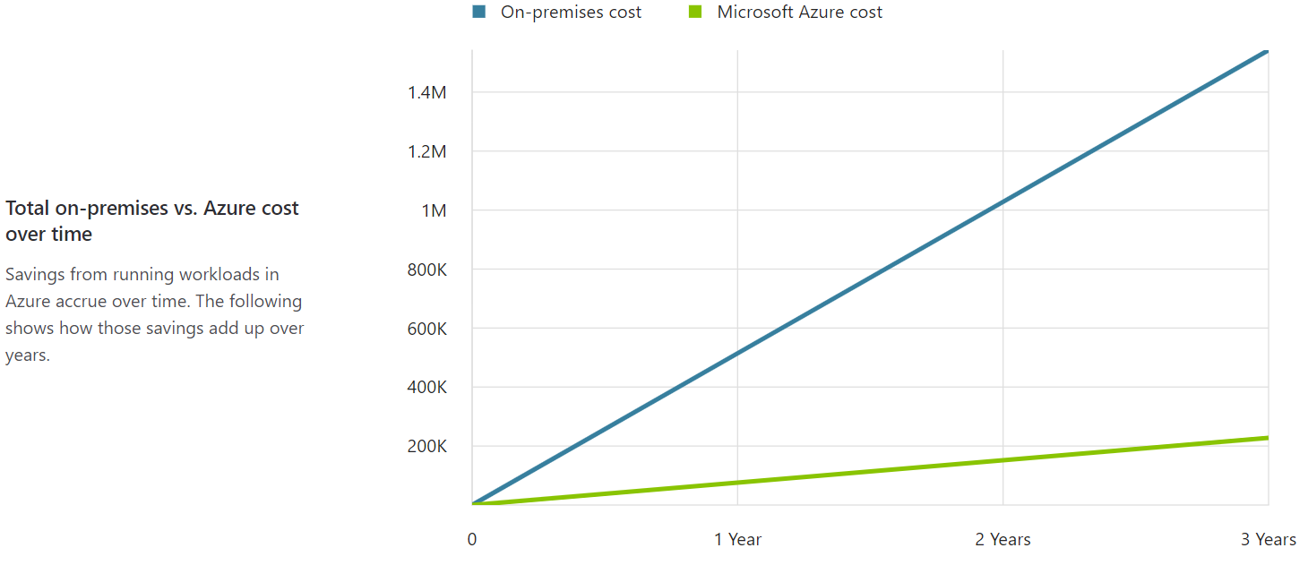

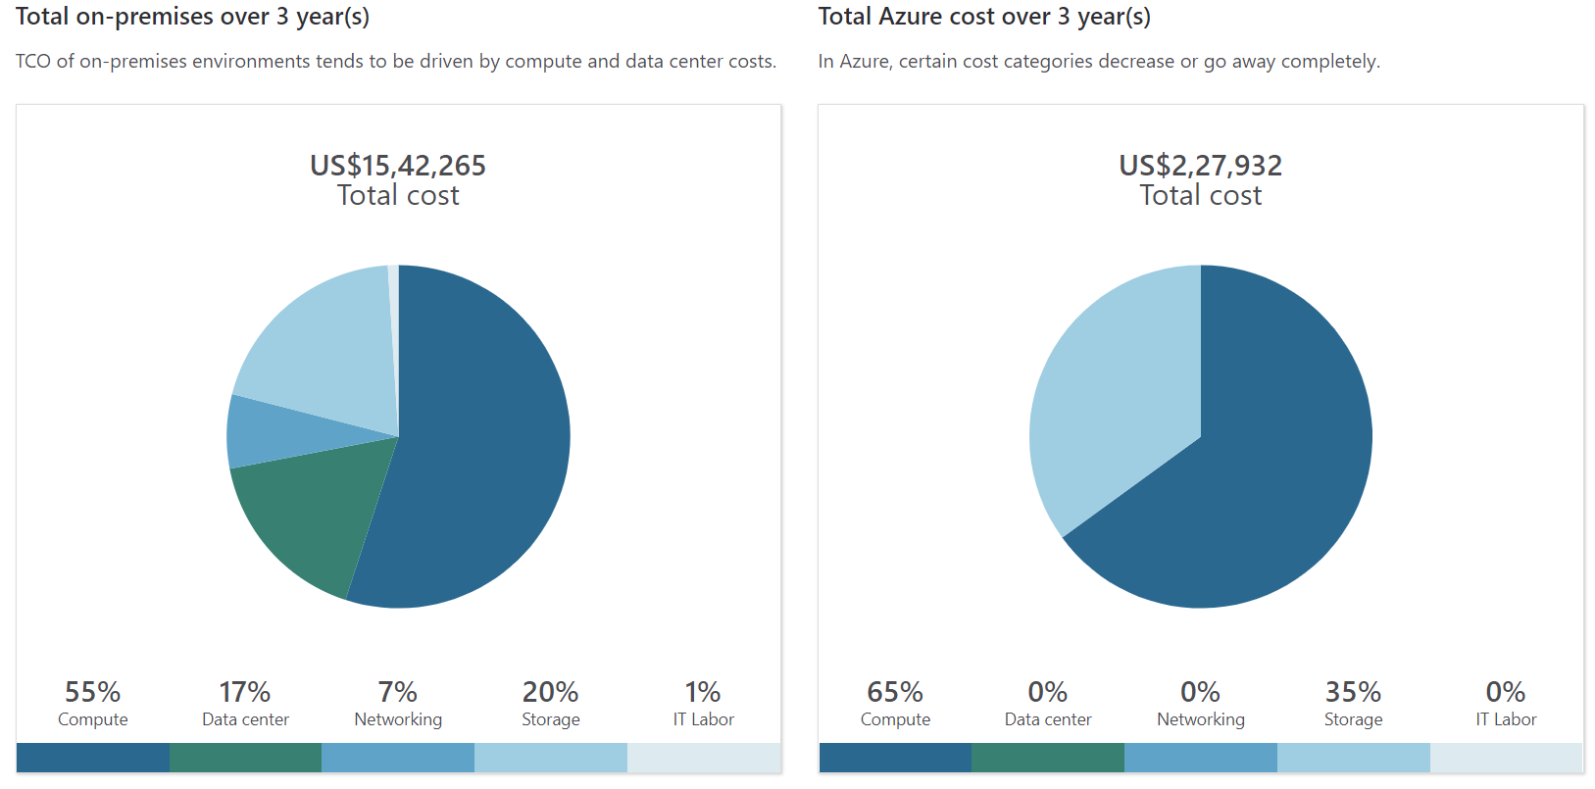

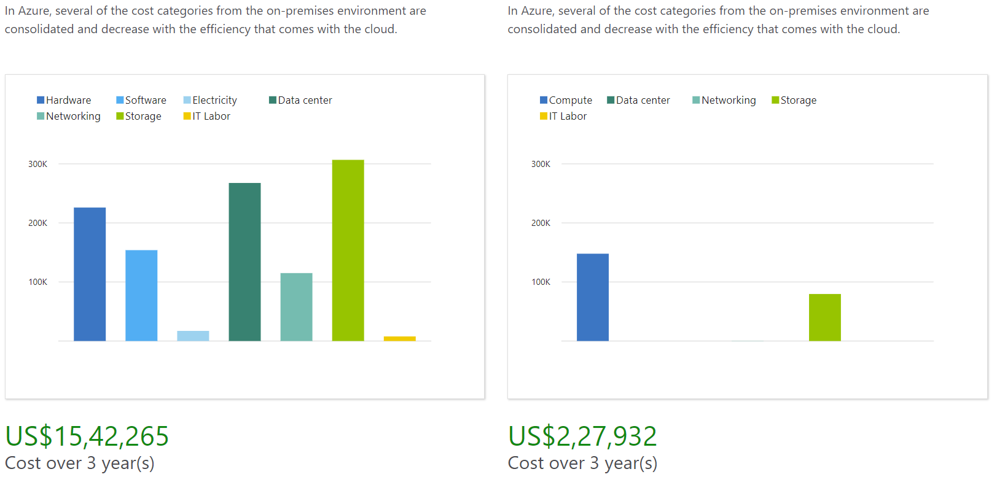

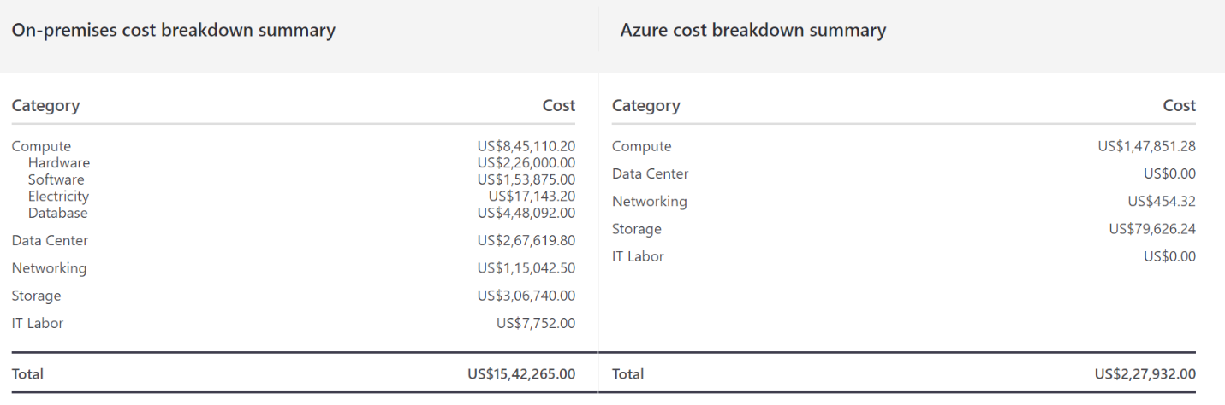

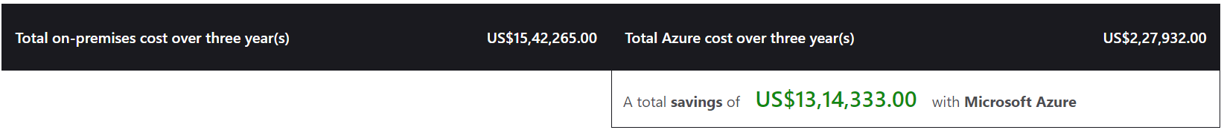

[**Azure Pricing Calculator**](https://azure.microsoft.com/en-in/pricing/calculator/)**:**

The Azure Pricing Calculator helps you to predict the estimated monthly Azure bill for any Azure workload. Once you have Azure services running, the Azure Portal helps you to monitor the actual costs that you have incurred.

The Azure Pricing Calculator helps you understand the costs of moving your technical estate to Azure, and to estimate pricing once your data and applications are in Azure. The calculator allows you to view the price for different sizes and configurations of your Azure Virtual Machines in terms of the machine’s CPU, memory, storage, location, and hours in use. You can add any combination of Azure services to the calculator and view the pricing for a complete solution. This allows you to make better decisions on your move to the cloud by expediting the cost component of the decision.

Example Scenarios: <https://azure.microsoft.com/en-in/pricing/calculator/>

**Step1:**

The above link directs to Azure Pricing calculator which is shown in the below image. To get the estimate of the Azure services select the required azure product or service. You can do a search for the products in the Azure platform in the search bar or you can navigate using the black boxes on the left.

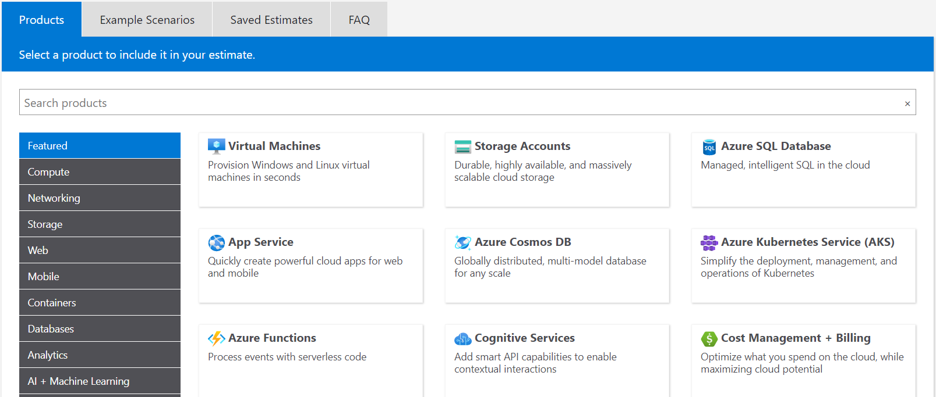

**Step 2:**

To start creating my estimate, I select the Azure SQL Database, and this takes me to the image shown below where I can start entering information about my database. The Name of the estimation report is “Estimate for the given scenario”.

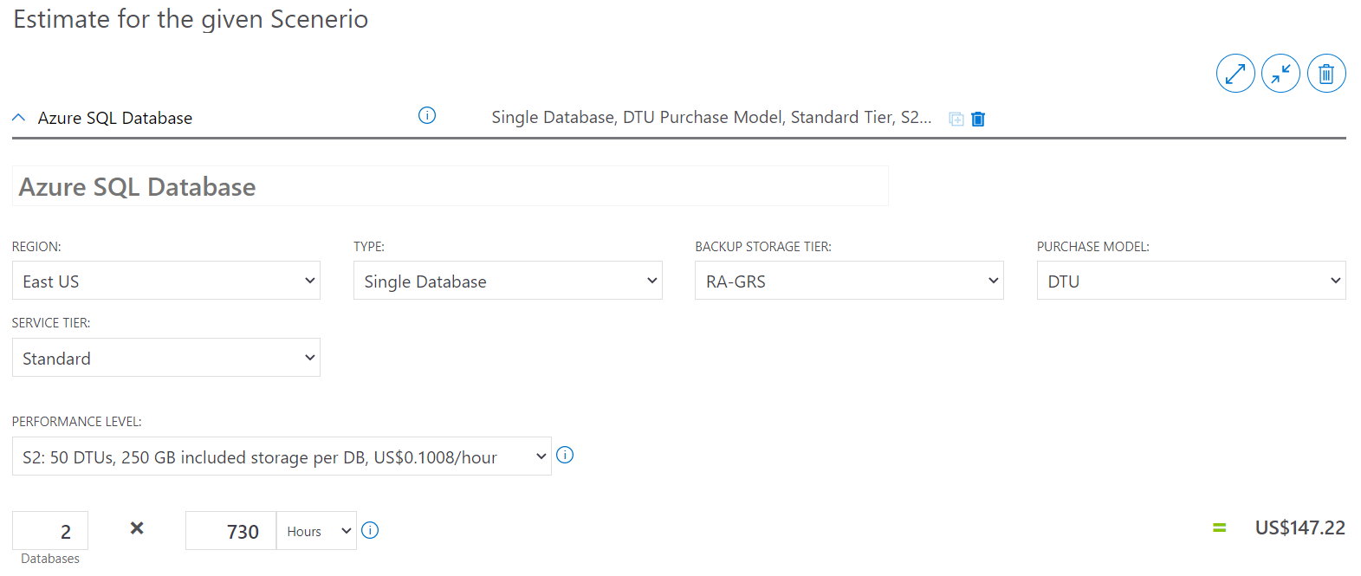

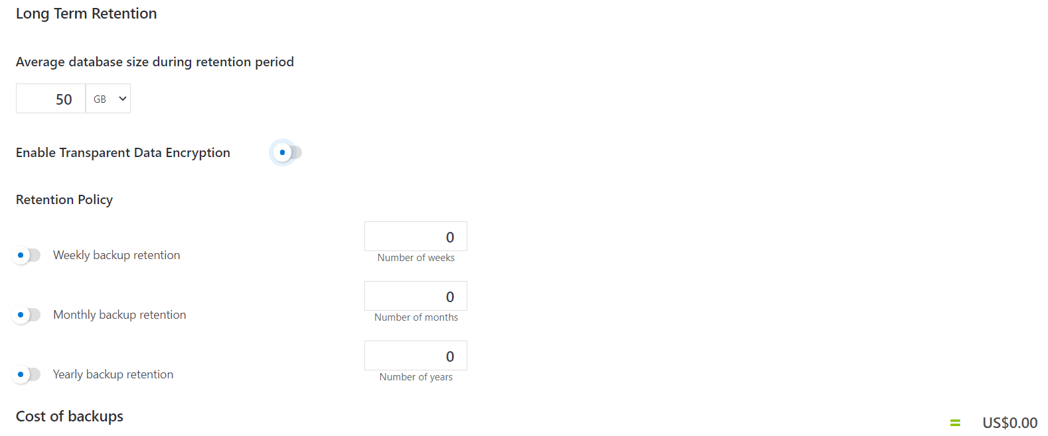

**Step 3:**

At the top you can enter a name; by default, it says ‘your estimate’ but you can name it whatever you want like if you’re working on specific project for example. I’ve named mine “Estimate for the given scenario”. As I’m picking an Azure SQL Database, I’m given options that pertain to that, so I must choose a region, what type of database, what service tier I want to use, etc. – things that apply to this database. Once I’ve made my selections it will compute the price for this service and will add that price at the bottom. There is also long-term retention option as shown in the above image. For our example we are keeping it as default.

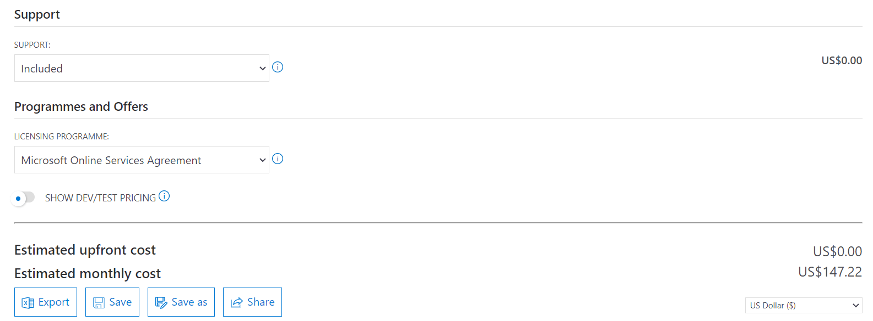

**Step 4:**

Finally, selection of support type needed, and Licensing program needed.

**Supports:**

* Developer Support: Developer support is for companies or individuals using Azure in a non-production environment or for trial and evaluation.
* Standard Support: Standard support is for small- or mid-size companies with minimal business-critical dependence on Azure.
* Professional Direct Support: Professional Direct support is for mid-size to large companies with substantial business-critical use of Azure.

**Licensing Program:**

* Microsoft Online Services Agreement: This is our most popular and flexible payment plan. With Azure pay-as-you-go pricing, there is no minimum purchase or commitment. Pay by credit card or invoice and cancel anytime.
* Enterprise Agreements: Large organizations often sign up for a Microsoft Enterprise Agreement (EA). By making an upfront usage commitment to Azure they earn several additional benefits—including flexible billing options and our very best prices.
* Microsoft Customer Agreement: As part of a new way of doing business with Microsoft, this new commerce model includes a digital customer agreement and enhanced billing and cost-management capabilities that provide a streamlined Azure purchasing experience for customers.

**Step 5:**

Once you’re done making the selections about the components you want to include in your estimate, you can scroll to the bottom for options for saving or exporting it. Saving it will save it to the portal, so you can come back and edit and change it as you need. You can also clone it and create a couple different estimates with some small variations. Another option is to export it which will dump this out to an Excel file, then you can email it and share it with your organization.

[**Azure Cost Management**](https://azure.microsoft.com/en-in/services/cost-management/)**:**

Azure Cost Management is a cost management solution that helps you use and manage Azure and other cloud resources effectively. Continuously monitor cloud consumption and cost trends. Below are the main feature that ACM provides:

Monitor your cloud spending**:** The reports available in Microsoft Azure Cost Management help you view your past usage and costs while also allowing you to project your future spending. These costs can be viewed in daily, monthly, or yearly views, so you can see trends and anomalies across smaller or larger time frames.

Increase your organizational Accountability**:** Microsoft Azure Cost Management reports have the ability to be broken down in different ways by using “cost entities” to split resources into different buckets. These entities are often aligned with specific projects or departments within your organization and can correlate with users or Azure subscriptions. Further, you can create “cost models” to split resources based on tags from your raw billing information.

LINK: <https://azure.microsoft.com/en-in/services/cost-management/#features>

## Initial Organization Alignment

Putting the business first in cloud initiatives will require a united front that combines executive leadership, lines of business managers, and end-users. The most important aspect of any cloud adoption plan is the alignment of people who will make the plan a reality. No plan is complete until you understand its people-related aspects. It will become important to establish long-term organizational alignment, especially as cloud adoption scales across the business and IT culture.

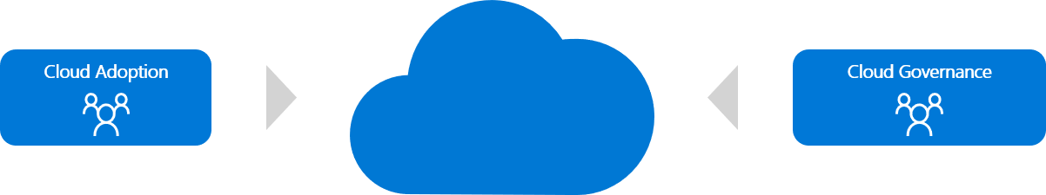

Full organization alignment is not a required component of the cloud adoption plan. However, some initial organization alignment is needed. To maintain the speed and control over the cloud migration it is important to assign a team for cloud adoption and cloud governance. This teams will be accountable for cloud migration quickly and will minimum risks. The cloud governance team provides the necessary checks and balances to ensure that cloud adoption doesn't expose the business to any new risks. When risks must be taken, this team ensures that proper processes and controls are implemented to mitigate or govern those risks.

## Skills Readiness Plan

For successful cloud adoption, it’s critical to ensure your people, IT and non-IT, are ready for this transformation (cloud migration). Agile employees who explore and learn new cloud technologies don't need to have that fear. They can lead the adoption of cloud services by helping the organization understand and embrace the associated changes. Below table will help to make cloud migration process smooth.

|  |  |  |  |  |
| --- | --- | --- | --- | --- |
| **Course name** | **Audience (Cloud Architect, IT, Admin, Ops)** | **Level (100, 200, 300, 400)** | **Source (MS Learn, Pluralsight, ESI)** | **Priority (high, mid, low)** |
| [Microsoft Cloud Adoption Framework for Azure](https://docs.microsoft.com/en-us/learn/modules/microsoft-cloud-adoption-framework-for-azure/index) | Admin, Devs, Cloud Architect, Business User, Cloud Engineer | 100 | MS Learn | High |
| [Azure Fundamentals](https://docs.microsoft.com/en-us/learn/paths/azure-fundamentals/) | Admin, Devs, Cloud Architect, Business User, Cloud Engineer | 100 | MS Learn | High |
| [Learn the Business Value of Azure](https://docs.microsoft.com/en-us/learn/paths/learn-business-value-of-azure/) | Business User | 100 | MS Learn | Mid |
| [Administering Relational Databases on Microsoft Azure](https://docs.microsoft.com/en-us/learn/certifications/exams/dp-300) | Cloud Engineer, Admin, Devs | 300 | MS Learn | Mid |

## Challenger Questions for Customers

Following are questions for customers

**Are You Looking to Save Money?**

Customers shall move their development and test operations to Azure. When you need new servers and supporting software licenses for development or test environment, Azure might be a great fit. In this regard, moving development and test to the cloud is a great way to get your feet wet with Azure while saving money on hardware and software licenses.

When customers have the on-premises infrastructure they have full authority of the data but also responsible for maintenance and upgrading costs of the server hardware, power consumption, and space. It’s relatively more expensive than cloud computing. After Cloud Migration Customers don't need not pay the charges of keeping and maintaining their servers. Organizations that opt for the cloud computing model need to pay only for the resources that they consume. As a result, the costs go down drastically. There is any number of costs that enter into the equation when considering on-premises versus cloud-based deployments.

* Software Licensing and Support
* Hardware
* Virtualization
* Power
* Storage
* Datacenter
* IT Staffing
* Application Development

**Is your organization looking to save time from maintaining on-premises servers?**

The downside of on-premise environments is that time associated with managing and maintaining all the solutions is much higher than we think. An on-premise setup requires in-house server hardware, software licenses, integration capabilities, and IT employees on hand to support and manage potential issues that may arise. This doesn’t even factor in the amount of maintenance that a company is responsible for when something breaks or doesn’t work. Azure will host all workloads for the organization. This allows companies to pay on an as-needed basis and effectively scale up or down depending on overall usage, user requirements, and the growth of a company.

**Is your organization looking for scalable infrastructure solution? OR is your database scalable?**

The inability to predict the growth of the business can directly result in a multitude of performance issues for an organization’s application. When growth occurs or is expected in the near future, businesses need to review, test, and change their systems. In the case of on-premises infrastructure, you need to plan well in advance to changes in demand because of the time necessary to research, justify, order, and deploy the hardware. Without taking growth into consideration, you face slowdowns, bottlenecks, and other problems that directly affect customers and can easily impact business as well. After Cloud Migration Cloud resources can be rapidly adjusted to accommodate specific demand for business. It offers the flexibility to scale up or down depending on your specific business needs.

**Does your organization lack appropriate expertise in Security to keep the resources safe from hackers?**

Customers need to actively manage security issues while maintaining on-premises resources or when scaling up infrastructure. Without the proper attention given to keeping valuable and sensitive systems and assets secure, businesses put themselves in danger. If the organization lacks appropriate expertise, it risks significant exposure. For many organizations, data encryption at rest is a mandatory step towards data privacy, compliance, and data sovereignty. Azure Cloud provides superior Data Security with features like

* Data Discovery & Classification
* Vulnerability Assessment
* Advanced Threat Protection

**Is 99.9999% uptime necessary for your business?**

For many organizations they want their application or databases up and running all the time. InformationWeek shed light on a [2011 study](http://www.informationweek.com/storage/disaster-recovery/it-downtime-costs-265-billion-in-lost-re/229625441) done by CA Technologies which tried to provide an idea of what downtime costs businesses on a broad scale. This survey found that a total of $26.5 Billion is lost each year due to IT downtime. That’s an average of about $55,000 in lost revenue for smaller enterprises, $91,000 for midsize organizations, and a whopping $1 million+ for large companies. Just in implementation, training, and cost savings alone, the cloud is easier and cheaper. But when you consider these hidden costs, the migrating to the azure cloud is the good choice.

**Does Software Customization or Deployment often lead to reliability issue, support issue or Lengthy Deployment times?**

Software Customizations can lead to reliability and software update issues. PaaS and SaaS Azure platforms are quite stable. Updates are iterative. Software Deployment complexity means, lengthy difficult and unstable environment deployments. SaaS will be very quick to implement and have stable environment.

**Is your organization failing to meet the latency requirement for the customers due to lack of data centers in different regions?**

Businesses will have their customers all around the world but having data centers in only region will make the latency problem unavoidable. The data will be hundreds or thousands of miles away from the customers' locations. In today’s business applications, where users expect real-time response and data should be generated at many endpoints. Building such on-premises infrastructure to minimize latency is often costly. Azure will be more cost effective when building out multi-site/ geo-redundant server and storage.

**Is your database optimize?**

There are several factors that can impact database performance including provisioning, database sprawl, poor database designs, coding mistakes, and the addition of more data and users. Azure provides auto-provisioning which simplifies and speeds deployment making it easier and faster to deploy applications across the enterprise.

## Roadmap of Migration from IaaS to PaaS

This section will specifically discuss the phases of Migration from IaaS to PaaS:

**Phase 01: On-premises to IaaS**

When customers move from on-prem to Azure with existing workload, they generally prefer IaaS option, because the project less complex (simple lift and shift).

Migration to [Azure SQL VM *(IaaS)*](https://docs.microsoft.com/en-us/azure/azure-sql/virtual-machines/windows/sql-server-on-azure-vm-iaas-what-is-overview)allows you to run SQL Server inside a fully-managed virtual machine (VM) in the Azure cloud. Best for migrations and applications requiring OS-level access. SQL virtual machines are lift-and-shift ready for existing applications that require fast migration to the cloud with minimal changes or no changes. SQL virtual machines offer full administrative control over the SQL Server instance and underlying OS for migration to Azure. The VM Machine in Azure can be accessed from any RDP (Remote Desktop Protocol) Client. It can be a Machine with the Windows OS installed (recommended), a Mac, or any OS with RDP installed.

Azure VMs are great for existing applications that require fast migration to the cloud with minimal changes. VMs are well suited for rapid development and test scenarios when you do not want to buy on-premises non-production SQL Server hardware.

**Phase 02: IaaS to PaaS**

If a system is new to build or it is up and running successfully for a while, it’s time to rethink on Azure utilization and save resources and money. Hence, PaaS will be the best to go for in cloud.

Migrating to [Azure SQL Database Managed Instance](https://docs.microsoft.com/en-us/azure/azure-sql/managed-instance/sql-managed-instance-paas-overview) is much similar to migration from on-premises to Azure SQL VM but comes with many additional benefits. Azure SQL Database Managed Instance is another flavor and deployment option of Azure SQL Database. They are a managed Platform as a Service (PaaS) database offering, but with a far greater level of equality with the retail SQL Server product that we are all familiar with. Managed Instances give you capabilities that previously prevented many database systems from being moved to Azure SQL Database, including cross-database queries, lack of SQL Server Agent, and other items.

Below is the list of reasons for migrating from IaaS to Azure PaaS:

* Isolated environment (single-tenant service with VNET, dedicated compute and storage resources)
* Customer configurable backup retention and recovery
* Database Advisor and Log Analytics for advanced workload analysis
* Automatic database tuning and maintenance for predictable performance
* Monitor, troubleshoot and manage at scale
* Azure Portal functionality for manual service provisioning and scaling
* Azure AD authentication, single sign-on support
* Encryption of the data in transit and rest with customer-provided encryption keys
* No patching and version upgrade overhead